中二級 中國歷史科 教學設計示例
（供收錄非華語學生的學校參考使用）
宋代的政治發展概況

一.建議教節：5節

二.預期學習成果:
完成本課題後，學生能：
- 了解宋朝的政治特色。（知識內容）
- 認識宋朝與周邊民族關係的發展。（知識內容）
- 掌握宋朝與香港的關係。（知識內容）
- 透過閱讀文字資料、地圖、圖像、時間線、影片等，比較異同，分析史事。（知識內容、技能）
- 欣賞宋代士大夫及岳飛獻身家國的精神。（情意、態度）

三.教學建議：
- 因應非華語學生的中文能力，工作紙較多圖像，部分題目輔以英文，協助學生理解內容。
- 題型包括選擇、圈示、填充等。思考題可因應學生的語文程度，或以口語回答。
- 教師可按學生學習情況加入討論環節，以增加學生之間的互動。
- 教師可鼓勵學生觀看網上影片，提升學習興趣。
- 教師教授課題時，除教授相關史實外，亦須指導學生認識中國的文明和文化，促進他們認識中國文化的特質。
- 教師可因應學生的程度而選取適合的部份或教學活動施教。

四.教學方案：
內容重點 | 流程 | 相關教材
課節一至三  宋朝的政治發展概況 | - 講解關鍵詞  - 運用時間線及地圖等說明宋朝的政治發展概況  - 透過圖像及文字資料等，解釋宋朝的政治特色  - 運用圖表及圖像等，說明宋朝的政治改革 | 時間線、  地圖、  圖表、  圖像、  文字資料、  工作紙
課節四  宋朝與周邊民族關係的發展 | - 運用地圖、圖像、影片及時間線等，說明外患與宋朝滅亡的關係 | 地圖、  圖像、  時間線、  影片、  工作紙
課節五  宋朝與香港的關係 | - 通過文物及圖像，說明宋朝與香港的關係 | 文物、  圖像、  工作紙

備註：
- 學校可參考本教學計劃以調適課程內容，以配合學生的需要；
- 可因應學生的中文程度而刪去或減少當中的英文句子或詞彙；
- 可同時參考課程發展處出版的其他教材或為本課綱準備的其他示例；
- 可考慮向學生提供更多全方位學習經驗，如實地考察、參觀博物館等等。

XXX中學
中二級 中國歷史科課堂工作紙
宋代的政治發展概況

姓名Name：________________ 成績Grade：_____／_____
班別Class：__________( ) 批改日期 Date of Marking：

學習重點(Learning Objectives)
- 宋朝的政治特色(The political characteristics of the Song Dynasty)
- 宋朝與周邊民族的關係(The relationship between the Song Dynasty and other ethnic groups)
- 宋朝與香港的關係(The relationship between the Song Dynasty and Hong Kong)

- 本節關鍵詞(Key Terms)

 | 英文詞彙 | 中文詞彙/粵語拼音 | 中文詞彙/普通話拼音
1 | Song Dynasty | 宋朝(sung3 ciu4) | 宋朝(Sòng cháo)
2 | Centralization of power | 中央集權(zung1 joeng1 zaap6 kyun4) | 中央集權(zhōng yāng jí quán)
3 | Bureaucratic politics | 文人政治(man4 jan4 zing3 zi6) | 文人政治(wén rén  zhèng zhì)
4 | Fan Zhongyan | 范仲淹(faan6 zung6 jim1) | 范仲淹(Fàn Zhòngyān)
5 | Wang Anshi | 王安石(wong4 on1 sek6) | 王安石(Wáng ānshí)
6 | Sima Guang | 司馬光(si1 maa5 gwong1) | 司馬光(Sīmǎ Guāng)
7 | factional struggle between reformists (New Party) and anti-reformists (Old Party) | 新舊黨爭(san1 gau6 dong2 zang1) | 新舊黨爭(xīn jiù dǎng zhēng)
8 | Liao | 遼(liu4) | 遼(Liáo)
9 | Jin | 金(gam1) | 金(Jīn)
10 | Yue Fei | 岳飛(ngok6 fei1) | 岳飛(Yuè Fēi)
11 | Mongol | 蒙古(mung4 gu2) | 蒙古(Měng Gǔ)
12 | Sung Wong Toi | 宋王臺(sung3 wong4 toi4) | 宋王臺(Song Huáng Tái)

- 本節概要(Key Points of the Chapter)

「文人政治」是宋朝的政治特色。 | Bureaucracy was the political characteristic of the Song Dynasty.
宋朝與邊境民族政權有時打仗，有時和好，北宋和南宋的滅亡與邊境民族入侵有關。 | The Song Dynasty fought and / or made peace with the surrounding frontier ethnic regimes from time to time. The downfall of both the Northern and the Southern Song Dynasty were related to foreign invasions.
南宋末年，二帝被元兵追迫而南遷，曾逃難到香港聖山。 | At the end of the Southern Song Dynasty, the last two emperors were chased by the troops of the Mongol Empire and fled south to Hong Kong. They took refuge at the Sacred Hill of Hong Kong.

課節一至三：宋代的政治發展概況(An overview of the political development of the Song Dynasty)

I. 宋朝的發展概況 (An overview of the history of the Song Dynasty)
趙匡胤(宋太祖)結束五代十國的亂局，統一中國。(Zhao Kuangyin (Emperor Taizu of the Song Dynasty) ended the tumultuous Five Dynasties and Ten Kingdoms Period, and reunified China.)

資料一：宋朝發展的時間線 (Source A : Historical timeline of the Song Dynasty)
E
AD
公元

H
G
F
D
C
B
A

900 950 1000 1050 1100 1150 1200 1250 1300 1350 1400
五代十國 Five Dynasties and Ten Kingdoms
(907年―979年)
 |  | 北宋Northern Song Dynasty  (960年―1127年) |  |  |  |  | 南宋Southern Song Dynasty  (1127年―1279年)
 | 遼Liao(916年―1125年)
金Jin
(1115年―1234年)
 |  |  |  | 西夏Western Xia (1038―1227年)
元朝Yuan Dynasty
(1271年―1368年)

亞、非及其他地區歷史  (History of Asia, Africa and other regions) | 年份  (公元)  AD | 宋朝歷史  (History of the Song Dynasty)
 | 960 | A. 趙匡胤建立宋朝(Zhao Kuangyin established the Song Dynasty)
越南丁朝建立(Dinh Dynasty was established in Vietnam) | 968
 | 1043 | B. 范仲淹提出改革(Fan Zhongyan proposed reform)
塞爾柱突厥佔領巴格達(Seljuk Turk occupied Baghdad) | 1055
非洲阿爾摩哈德王朝建立  (Almohad Dynasty was established in Africa) | 1061
 | 1069 | C. 「王安石變法」開始(Wang Anshi's reforms started)
 | 1125 | D. 北宋聯金滅遼(Northern Song Dynasty formed an alliance with the Jin Dynasty to conquer the Liao)
高麗成為金國的藩屬(Goryeo became the tributary state of the Jin Dynasty) | 1126
 | 1127 | E. 北宋滅亡(The Northern Song Dynasty was collapsed.)  趙構建立南宋(Zhao Gou established the Southern Song Dynasty)
 | 1142 | F. 岳飛被處死(Yue Fei was executed)
日本幕府時代開始(The beginning of the shogunate period in Japan) | 1192
德里蘇丹國建立(Delhi Sultanate was established) | 1206
 | 1233 | G. 南宋聯蒙滅金(Southern Song Dynasty allied with the Mongol to conquer the Jin Dynasty)
朱羅王朝滅亡(Chola Dynasty was collapsed) | 1279 | H. 南宋滅亡(The Southern Song Dynasty was collapsed)
根據資料一，回答以下問題。(Study Source A and answer the questions.)

1. 以下哪個朝代的管治時間最長？試圈出答案。(Which of the below dynasty had the longest rule? Circle your answer.)
A. 五代十國(Five Dynasties and Ten Kingdoms)
B. 宋朝(Song Dynasty)
C. 元朝(Yuan Dynasty)

2. 宋朝分為(Song Dynasty was divided into)：
北宋和南宋 (Northern Song Dynasty and Southern Song Dynasty)

3. 填充(Fill in the blank)
宋朝共有319年。(The Song Dynasty lasted for 319 years.)

4. 配對(Matching)
趙匡胤  (Zhao Kuangyin) |  | - 建立南宋(established the Southern Song Dynasty)
趙構  (Zhao Gou) |  | - 建立北宋(established the Northern Song Dynasty)

5. 課堂活動(Classroom activity)
請不同族裔同學的代表向班中同學簡介所屬族裔在宋朝時期發生的重要歷史。可以口語回應。(NCS students may introduce to their classmates the important historical events of their ethnic groups happened in the Song Dynasty. Students can respond verbally.)

資料二：後周時期的地圖(公元915-960年) (Source B : Map of Later Zhou Period)(915-960)
唐朝滅亡後，中國進入接近半個世紀的割據亂局。在北方出現「五代」，南方出現「十國」（北漢除外）。以下是「五代」最後一個朝代 – 後周時期的地圖。
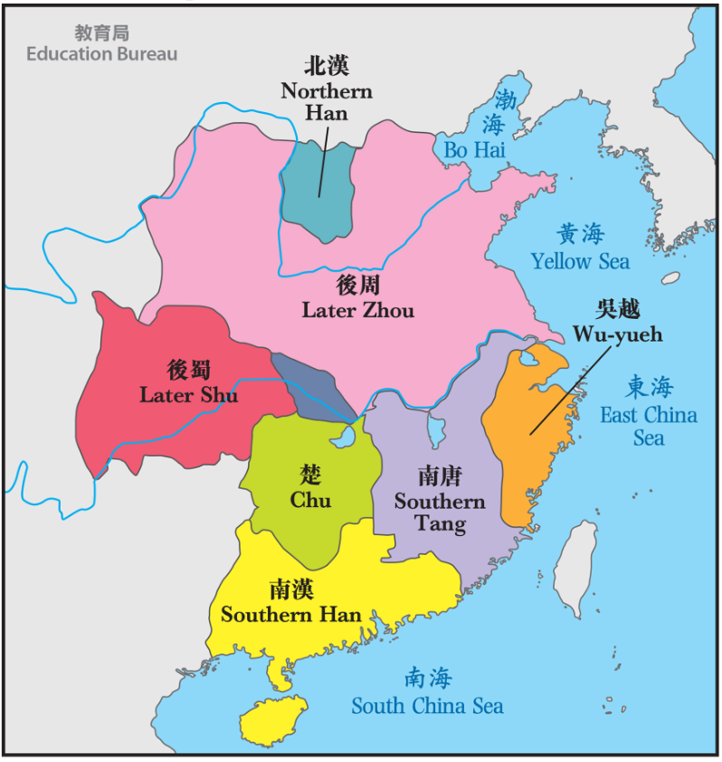
(China was plunged into half a century of fragmentation and rebellion after the downfall of the Tang Dynasty. There had been Five Dynasties in northern China and over Ten Kingdoms in the south (except Northern Han). This is the map of the Later Zhou, the last dynasty of the Five Dynasties.)
6. 根據資料二，請形容五代十國時期是統一的國家還是分裂的國家？試圈出答案。(According to Source B, was China unified or divided in the period of Five Dynasties and Ten Kingdoms? Circle your answer.)
A. 統一(Unified)
B. 分裂(Divided)
資料三：北宋地圖(公元1111年)(Source C : The map of the Northern Song Dynasty)(1111)
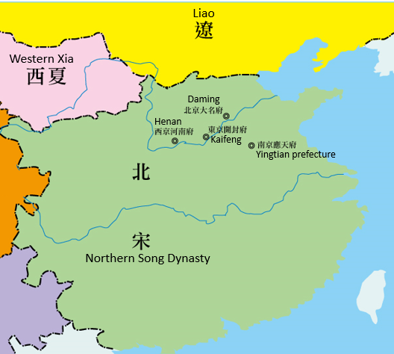

資料四：南宋地圖(公元1208年) (Source D: The map of the Southern Song Dynasty)( 1208)
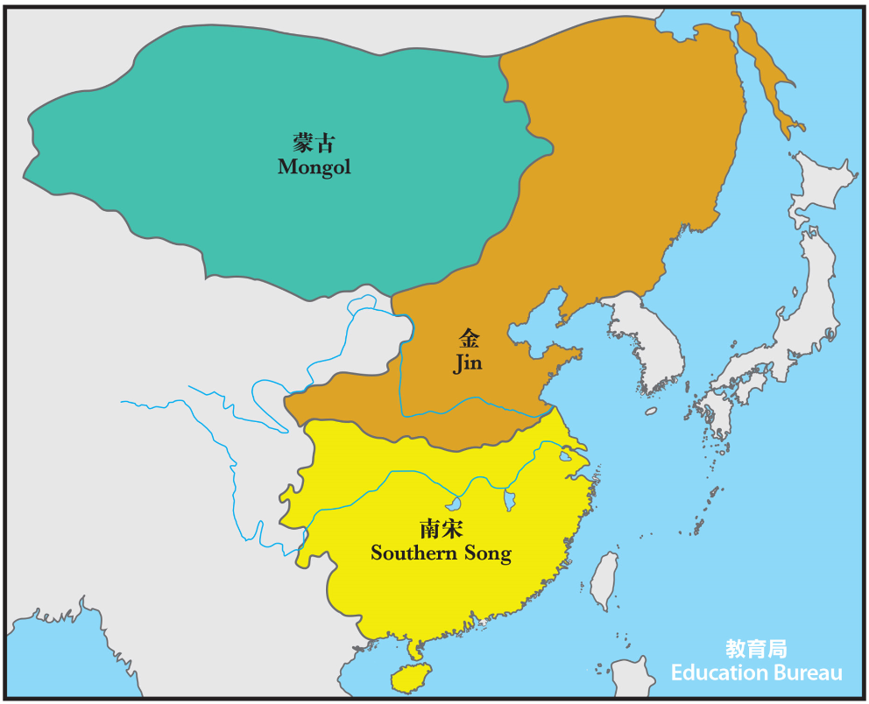

資料五：元朝地圖(公元1330年) (Source E: The map of the Yuan Dynasty)(1330)

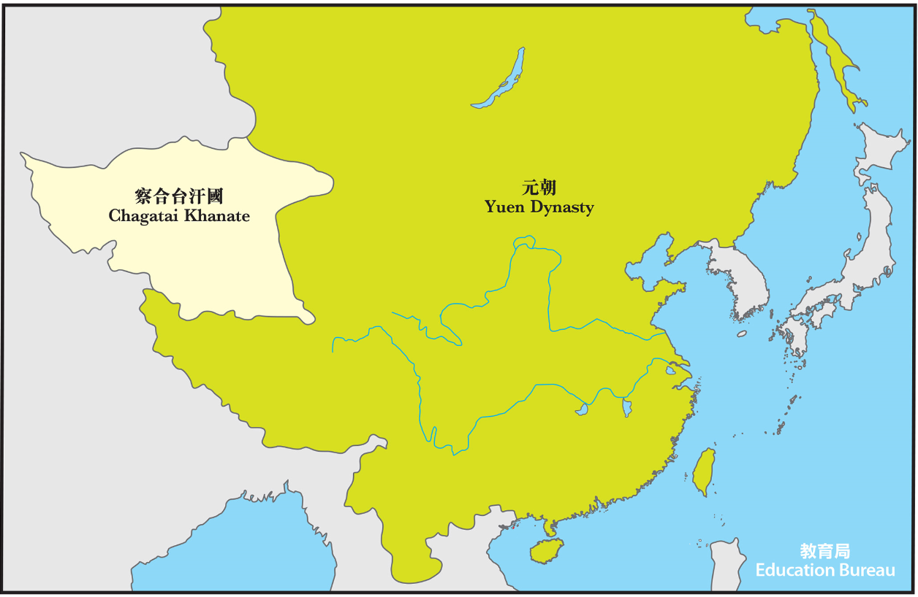
7. 根據資料二至五，哪個朝代的版圖最大？哪個最小？(Study Source B to Source E, which dynasty’s territory was the biggest? Which one was the smallest?)
元朝的版圖最大，南宋的版圖最小。(The territory of the Yuan Dynasty was the biggest. The territory of the Southern Song Dynasty was the smallest.)

小總結(A short summary)
宋朝由宋太祖建立，結束了五代十國的分裂時代。(The Song Dynasty was founded by Emperor Taizu of the Song Dynasty. He ended the division period of the Five Dynasties and Ten Kingdoms.)
宋朝分為北宋和南宋，版圖較元朝小。(The Song Dynasty was divided into Northern Song Dynasty and Southern Song Dynasty. The territory of the Song Dynasty was smaller than the Yuan Dynasty.)

II. 宋朝的政治特色(Political characteristics of the Song Dynasty)
「文人政治」是宋朝的政治特色。(“Bureaucratic politics” was the political characteristics of the Song Dynasty.)
「文人政治」的意思是主要由科舉出身的文官管理政事。(“Bureaucratic politics” means that the government administration was mainly in charge by the scholar-officials who passed the civil-service examinations.)

A. 宋朝的政治概況(An overview of the political development of the Song Dynasty)

宋朝政府把軍政大權收歸於中央，實行文人政治，這樣有助穩定政局。(The Song government centralized most of the power, both in the civil and military aspects, and implemented the system of bureaucratic politics. This helped to create a more stable government.)

資料一：陳橋兵變(Source A : Mutiny at Chen Bridge)
公元960年，在陳橋驛(今河南省)發生了兵變。午夜時，眾將以黃袍(黃袍只供皇帝穿著)加在趙匡胤身上，擁立他為皇帝。趙匡胤領兵佔領後周首都，成為北宋的開國君主。(In 960, Mutiny at Chen Bridge made Zhao Kuangyin, the Later Zhou commander, the founding ruler of the Northern Song Dynasty. In a midnight of the year 960, a mutiny took place at the Chen Bridge relay station (nowadays’ Henan Province). Zhao Kuangyin was dressed by his soldiers in an yellow imperial robe, a costume only the emperor could wear. This proclaimed him as their leader and Zhao Kuangyin led troops into the Later Zhou’s capital. Zhao became the founding ruler of the Northern Song Dynasty.)
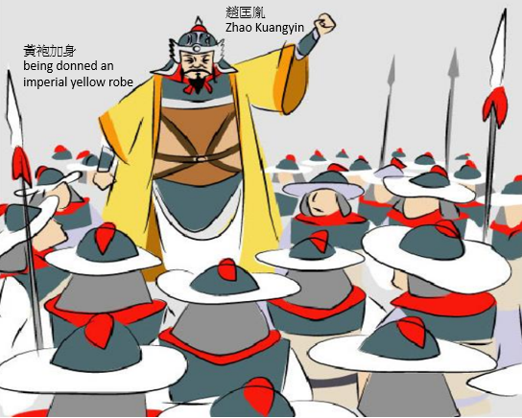

(圖片來源：教育局小學常識科學與教資源套（歷史與文化）https://www.edb.gov.hk/attachment/tc/curriculum-development/kla/general-studies-for-primary/lt_resource_pri_gs_hist_culture/LT_2_4_story_6.pdf，觀看日期：2020年9月1日。)
1. 從資料一可見，五代十國在政局方面有何特別？(Study Source A, what was the characteristic of the political situation of the Five Dynasties and Ten Kingdoms Period?)
五代多武人專政，以兵變奪取帝位的事情常有發生。(The political situation at that time was dominated by military men. They would stage mutinies and forced emperors to abdicate the throne.)

資料二：雪夜訪普圖(Source B :Painting “Xue Ye Fang Pu Tu”)
2. 請觀看雪夜訪普圖 (Please view the painting “Xue Ye Fang Pu Tu”)
(故宮博物院 The Palace Museum) 北京(Beijing)
https://en.dpm.org.cn/dyx.html?path=/tilegenerator/dest/files/image/8831/2007/0007/img0011.xml

此圖描繪宋太祖夜訪大臣趙普，討論國家大事。你認為宋太祖在開國之初面對甚麼急需解決的問題？可以口語回應。(This painting was about Emperor Taizu of the Song Dynasty visiting Zhao Pu, his trusted minister, at a snowy night to discuss affairs of the state. What were the urgent problems that Emperor Taizu of the Song Dynasty faced? You can respond verbally.)
教師指引：教師可指導學生留意五代十國的政局特點及趙匡胤奪位的背景。
參考答案：
- 收回武將兵權(removal of power from the military generals)
- 加強中央集權(strengthening of the centralization of power)

資料三：宋朝中央集權(Source C : Centralization of power of the Song Dynasty)
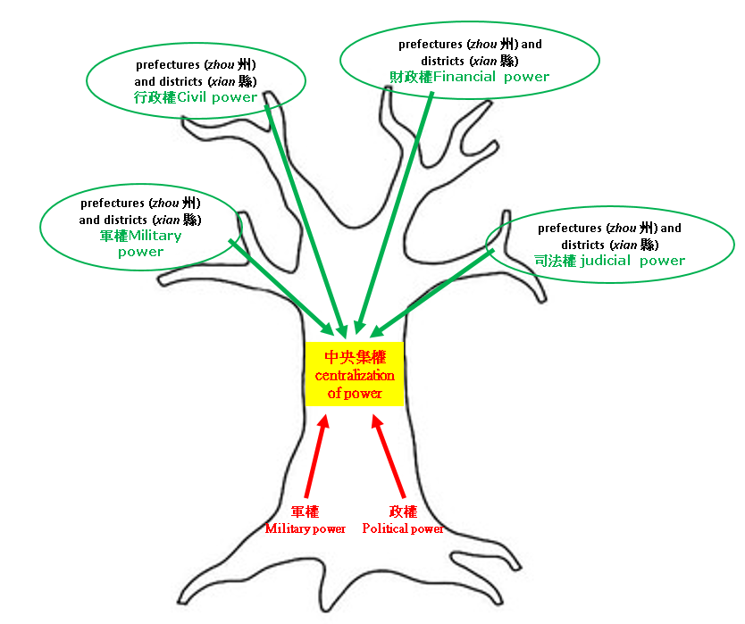

資料四：蒙兀兒帝國的中央政府(Source D : The central government of the Mughal Empire)

在十六至十七世紀，蒙兀兒帝國統治大部份今日的印度及巴基斯坦地區。(The Mughal Empire ruled most of nowadays’ India and Pakistan in the 16th and 17th centuries.)
蒙兀兒帝國皇帝 - 阿克巴建立中央集權制，權力集中於皇帝一身，由4名重要的大臣輔助。他們分別是宰相「維齊爾」；掌握財政的「迪萬」；掌握軍事的「米爾·巴克希」；主管宗教的「薩德爾-烏斯-蘇杜爾」。他們的任免及升降均由皇帝決定。(Akbar’s central government consisted of four departments, each presided over by a minister: the prime minister (wakīl), the finance minister (dīwān), the paymaster general (mīr bakhshī), and the director of the religious matters (ṣadr al-ṣudūr). They were appointed, promoted, and dismissed by the emperor.)

根據資料三及四回答題目。(Study Sources C and D, and answer the questions.)

3. 宋初實行中央集權有何好處？試圈出答案。答案可多於一個。(What were the advantages of the implementation of centralization of power in the early Song Dynasty? Circle your answer. There may be more than one correct answer.)
A. 促進經濟發展(enhancement of the economic development)
B. 維護國家統一安定(creation of a stable situation within the empire )
C. 消除唐代後半期以來的割據政權(ending of the political divisions and rules among warlords since the second half of the Tang Dynasty)
D. 防禦邊境民族入侵(defence against foreign invasion)

4. 宋代和蒙兀兒帝國的中央政制有何相似的地方？試圈出答案。(What were the similarities between the political systems of the Song Dynasty and the Mughal Empire? Circle your answer.)
A. 加強中央集權(strengthening of the centralized power)
B. 提升君權(increase in the authority of the emperors)
C. 分散官員權力(division of power and the weakening in the authority of officials)
D. 以上皆是(all of above)

資料五：文人政治(Source E: Bureaucratic politic)
宋代的文人政治措施，包括禮待文人，如大開科舉，大幅度增加取士名額，提供豐厚官俸。(The measures of adopting bureaucratic politic in the Song Dynasty included preferential treatments to civil officials, for example, frequent recruitments of the large numbers of government officials through civil-service examination system, offering of high salaries to officials.)

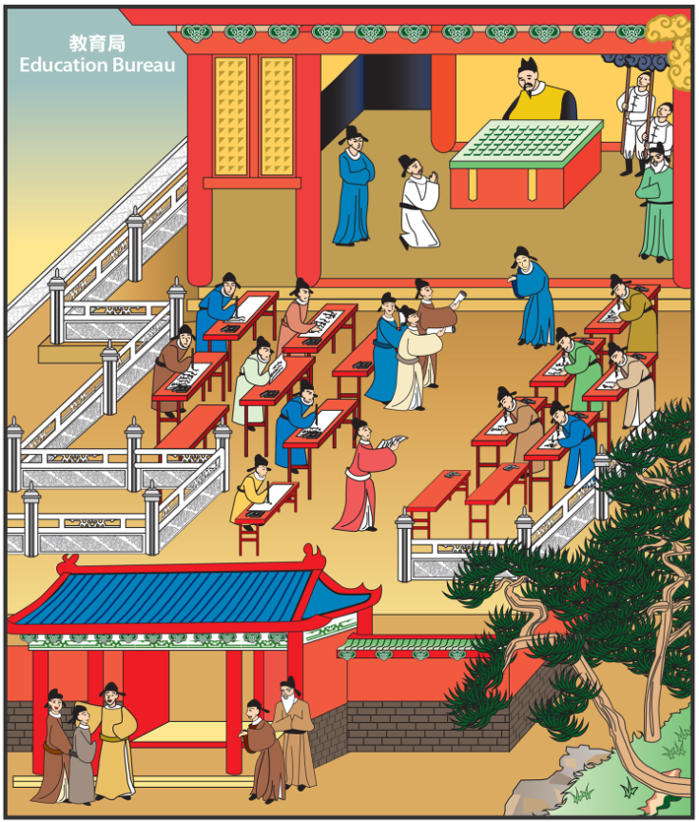
資料六：甄選官員制度(Source F : Selection System of officials)

圖中為宋代科舉考試的場景(The picture depicts the scene of the civil-service examination in the Song Dynasty.)
宋代科舉取士人數較唐代大幅提升，與宋代實行文人政治有密切關係。(Compared with the Tang Dynasty, the number of government officials were selected by the civil-service examination in the Song Dynasty increased significantly, which was closely related to the implementation of bureaucratic politics in the Song Dynasty.)

根據資料五及六回答題目。(Study Sources E and F, and answer the questions.)

5. 宋代採用甚麼制度甄選官員？試圈出答案。(How did the Song Dynasty select government officials? Circle your answer.)
A. 察舉孝廉(elevation based on the examinations of candidates' filiality and incorruptibility)
B. 九品中正制(System of the Rectification of the Nine Ranks)
C. 科舉制度(Civil-service Examination System)

6. 科舉制度是一種公開考試。在今天的高中學制之下，你知道香港學生進入大學前要參加哪個公開考試嗎？(The civil-service examination system was a kind of public examination. Under the current academic structure of the Senior Secondary education, which public examination Hong Kong students is required to sit for before they are admitted to universities?)
香港中學文憑考試(Hong Kong Diploma of Secondary Education Examination)

資料七：宋代書院(Source G: Academies of the Song Dynasty)
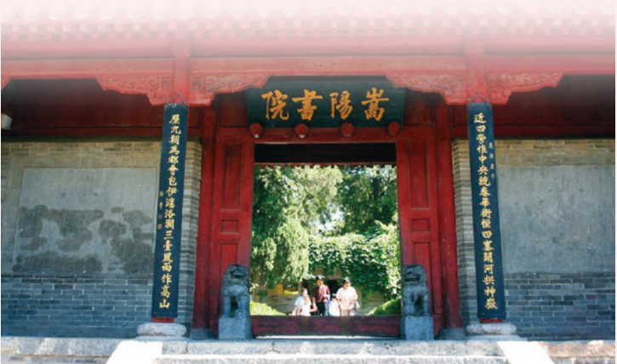
書院是中國古代的教育機構。為了向具潛質的考生提供教育。宋代是中國歷史上書院最為發達的時代。(Academies were educational institutions in ancient China. They provided potential candidates with schooling. Academies flourished in the Song Dynasty.)

(圖像來源：教育局課程發展處《想．創—中國歷史學與教資源套（第二輯）》。)
嵩陽書院是宋代四大書院之一。(The Academy of Songyang was one of the four great academies of the Song Dynasty.)
資料八：中古的歐洲大學(Source H: The universities of Europe in the Middle Ages)
隨著城市興起和工商業發展，社會也需要有一定文化知識的勞動者和經營管理者，於是城市學校應運而生。首先是意大利在11世紀建立法律學校、法國在12世紀建立巴黎大學、英國在12和13世紀分別建立牛津和劍橋大學。直至1500年全歐洲已有65所大學。(Accompanied with the development of urbanization, industry and commerce in Europe, there was a growing demand for literate labors and administrators in the society. Hence, urban schools were established. Schools of legal studies were founded in Italy in the 11th century firstly. Afterwards, the University of Paris , the University of Oxford and the University of Cambridge were founded in the 12th and 13th century accordingly. 65 universities were eventually founded throughout Europe until 1500 AD.)
(資料來源：朱寰、王建吉《世界古代中世紀史》)

根據資料七及八，回答題目。(Study Sources G and H, and answer the question.)

7. 請比較宋代和中古歐洲教育機構興起的原因。(Please compare the reasons for the emergence of educational institutions in the Song Dynasty and Europe in the Middle Ages.)
宋代(The Song Dynasty) | 中古的歐洲(Europe in the Middle Ages)
政府實行文人政治，書院為考生提供教育。  The Song Dynasty adopted bureaucratic politics. Academies were established to provide potential candidates with schooling. | 城市 興起和 工商業 發展，社會需要有一定文化知識的勞動者和經營管理者。Due to the growth of urbanization, industry and commerce, there was a growing demand for literate labors and administrators in the society.

小總結(A short summary)
宋初君主認為唐代面對最大的問題是武人專權。為防止問題再次發生，故實行中央集權及以文人掌政。(The early Song emperors believed that the centralization of power in the hands of the military generals was the main problem of the Tang government. To rectify this, power was centralized in the Song government and its civil officials instead.)

B. 宋朝的政治改革(The political reforms in the Song Dynasty)
北宋中期，國家很不景氣，皇帝分別任用范仲淹和王安石進行改革。(In mid-Northern Song, the whole country was deep in recession. Emperor Renzong and Emperor Shenzong of the Song Dynasty appointed Fan Zhongyan and Wang Anshi to start reforms respectively.)

資料九：北宋時間線 (Source I : Historical timeline of the Northern Song Dynasty)
AD
公元
1 |  | 2

A | B | C | D | E | F | G | H | I
960 976 997 1022 1063 1067 1085 1100 1125 1127

皇帝(Emperor) |  | 統治時期(Ruling Reign) | 政治改革(Political reforms)
A. | 宋太祖(Emperor Taizu) | 960年－976年
B. | 宋太宗(Emperor Taizong) | 976年－997年
C. | 宋真宗(Emperor Zhenzong) | 997年－1022年
D. | 宋仁宗(Emperor Renzong) | 1022年－1063年 | 1. 1043年－1044年(范仲淹變法(Fan Zhongyan’s reforms))
E. | 宋英宗(Emperor Yingzong) | 1063年－1067年
F. | 宋神宗(Emperor Shenzong) | 1067年－1085年 | 2. 1069年－1085年(王安石變法(Wang Anshi's reforms))
G. | 宋哲宗(Emperor Zhezong) | 1085年－1100年
H. | 宋徽宗(Emperor Huizong) | 1100年－1125年
I. | 宋欽宗(Emperor Qinzong) | 1125年－1127年
8. 在時間線上用「1」標示「范仲淹變法」的推行時段，用「2」標示「王安石變法」的推行時段。(Please mark “1” for the implementation period of “Fan Zhongyan’s reforms” and mark “2” for the implementation period of “Wang Anshi's reforms” on the timeline.)

9. 范仲淹開始推行變法距離北宋開國多少年？(寫出算式) (How many years did Fan Zhongyan start to implement reforms after the founding of the Northern Song Dynasty? (please write down the equations))
1043-960=83年(years)

10. 北宋在什麼時間進行改革？試圈出答案。(When did the Northern Song Dynasty begin to carry out reforms? Circle your answer.)
A. 北宋初年(early Northern Song Dynasty)
B. 北宋中期(mid- Northern Song Dynasty)
C. 北宋末年(late Northern Song Dynasty)

11. 填表(Fill in the table)
 | Fan Zhongyan’s reforms | Wang Anshi's reforms
變法推行了(reforms lasted for) | 1年(1 year) | 16年(16 years)

資料十：北宋財政收支的情況(Source J: Income and expenditure of the Northern Song Dynasty)
時間(Time) | 全年收入(緡)(Annual Income (thousand coins)) | 全年支出(緡)(Annual expenditure (thousand coins))
仁宗皇祐元年  (公元1049年）  (Emperor Renzong  (1st year of Huangyou)) | 126,251,964 | 出無餘(Nothing left)
英宗治平二年  （公元1065年）  (Emperor Yingzong  (2nd year of Zhiping)) | 116,138,405 | 131,864,453
資料來源：《宋史‧食貨下》。

12. 根據資料十，英宗朝，宋代政府的財政出現了什麼問題？試圈出答案。(Study Source J, what was the financial problem during the period of Emperor Yingzong? Circle your answer.)
全年支出 多/ 少 於全年收入。(The annual expenditure was more / less than the annual income.)

資料十一：北宋冗兵和冗官的情況(Source K: redundant soldiers and officials of the Northern Song Dynasty)
時期(period) | 兵員數量(number of soldiers) | 文武百官數量(number of military and civil officials)
太祖至太宗朝(公元968-976年)(Emperor Taizu to Emperor Taizong) | 378000 | ／
太宗朝(公元995-997年)  (Emperor Taizong) | 666000 | ／
真宗朝(公元1017-1021年)(Emperor Zhenzong) | 912000 | 9700
仁宗朝(公元1041-1048年)(Emperor Renzong) | 1259000 | 17000
英宗朝(公元1064-1067年)(Emperor Yingzong) | ／ | 24000
資料來源：《宋史》

13. 根據資料十一，有甚麼因素造成這財政狀況的轉變？(Study Source K, what was the cause for the change in this financial situation?)
冗兵和冗官越來越多(There were increases in both the redundant soldiers and officials.)

資料十二：宋朝軍力(Source L : Military power of the Song Dynasty)
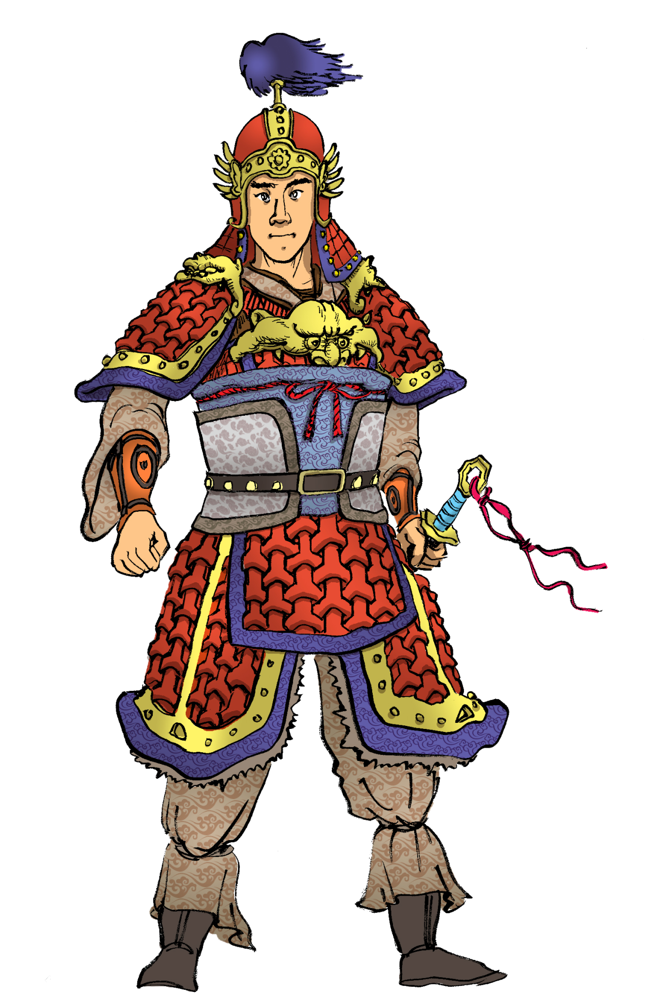
宋朝用文人帶領軍隊，但是他們大多不擅長作戰。(The Song Dynasty appointed civil officials as leaders of the army, but most of them were not good at fighting.)
地方政府只保留作戰能力較差的士兵。(Local governments could only keep weak armies.)

(圖表來源：教育局課程發展處《中國戰爭史教材套》，香港：教育局，頁78。)

14. 根據資料十至十二，以下哪一項不是北宋進行改革的原因？試圈出答案。(Study Sources J to L, which one was not the reason that the Northern Song Dynasty attempted to reform the administration? Circle your answer.)
A. 解決戰鬥力弱的問題(To solve the problem of weak military power)
B. 解決財政困難(To solve the financial problems)
C. 改善外交關係(To improve diplomatic relations)

資料十三：范仲淹(Source M :Fan Zhongyan)
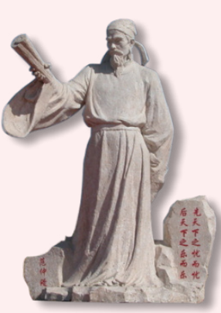
范仲淹(公元989-1052年) 是北宋政治家、軍事家及文學家。(Fan Zhongyan (989-1052) was a politician, military strategist and litterateur of the Northern Song Dynasty.)
我提出十項改革，嘗試改善管治，振興經濟及改革軍力。(I propose 10 reform measures and try to improve governance and the economic development, and strengthen the armed forces.)
不過，受到保守派反對而失敗了！(However, the reform measures are opposed by conservative officials and failed.)

(圖像來源：教育局課程發展處《想．創—中國歷史學與教資源套（第二輯）》。)

資料十四：王安石(Source N: Wang Anshi)
王安石（公元1021-1086年）是北宋傑出的政治家、思想家、文學家，唐宋古文八大家之一。(Wang Anshi (1021-1086) was an outstanding politician, thinker and litterateur of the Northern Song Dynasty. He was one of the Eight Great Prose Masters of the Tang and Song Dynasties.)
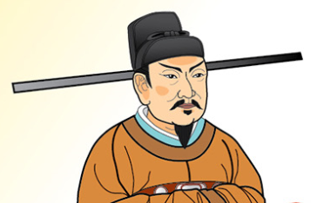
我從經濟、軍事及文教方面進行改革，以達致富國強兵的目的。(I initiate the economic, military and educational reforms to increase revenue and strengthen the armed forces.)
可是，受到各方反對，最後失敗了！(However, the reform measures are opposed by different factions and fail eventually.)

(圖像來源：教育局課程發展處《想．創—中國歷史學與教資源套（第二輯）》。)

資料十五：司馬光(Source O: Sima Guang)
司馬光(公元1019-1086年)是北宋政治家、文學家、史學家。(Sima Guang (1019-1086) was a politician, litterateur and historian of the Northern Song Dynasty.)
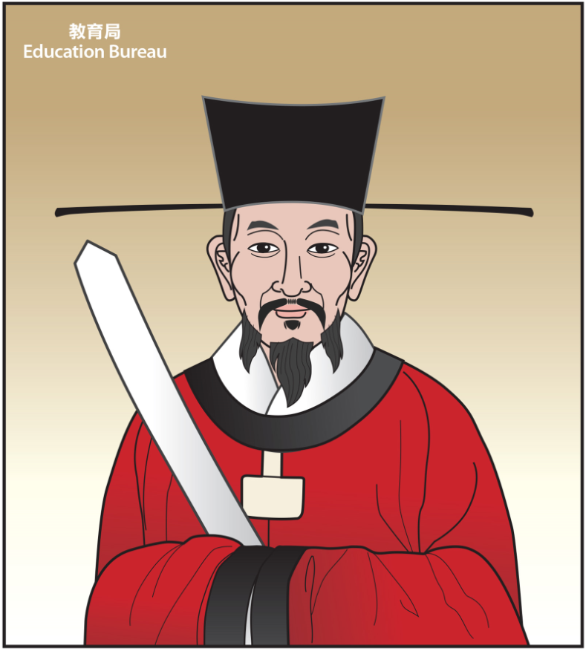
我帶領舊黨反對王安石新政。(I am the leader of the opponents of Wang Anshi’s Reforms.)
新舊黨爭持續了50多年。(The factional struggle between reformists (New Party) and anti-reformists (Old Party) lasts for more than fifty years.)

根據資料十三至十五，回答以下問題。(Study Sources M to O, and answer the questions.)

15. 范仲淹、王安石和司馬光是什麼出身？試圈出答案。(What was the background in common of Fan Zhongyan, Wang Anshi and Sima Guang? Circle your answer.)
A. 武人(military men)
B. 文人(civil official)

16. 承上題，由此可見宋朝有何政治特色？試圈出答案。(In continuation of the previous question, what was the political characteristics of the Song Dynasty? Circle your answer.)
A. 中央集權(Centralization of power)
B. 文人政治(Bureaucratic politics)
C. 武人專政(Domination of power by military men)
資料十六：宋朝及蒙兀兒帝國的主要經濟改革(Source P: Main economic reforms of the Song Dynasty and the Mughal Empire)
宋朝王安石變法(Wang Anshi's reforms of the Song Dynasty) | 蒙兀兒帝國的經濟改革(Economic reforms of the Mughal Empire)
方田均稅法:宋朝政府丈量土地，把田地分為五等，土地擁有者根據田地大小及等級交稅。(Measure the Land and Equitable Land Tax Policy: The Song government conducted a land survey and classified the farmlands into five grades. The owners would pay the land taxes according to the sizes and the grades of their farmlands.) | 按照肥沃程度將土地分為四等，並規定每一等級土地的税收標準(The land was divided into four classes according to their productivity. Land revenues were paid according to the classifications of land.)
青苗法：每逢青黄不接的季節，宋朝政府把糧食借給農民，到秋收以後，要他們跟官定的利息一道償還。(Green Sprouts Policy: The Song government provided loans with interest rates to peasants in the spring and received cash payments after the harvest in the fall.) | 蒙兀兒帝國為農民提供低息借貸，並在天然災難發生時豁免稅收，例如旱災和水災。(The Mughal Empire introduced small interest loans to farmers and granted revenues’ remission to farmers in case of natural disasters like draughts or floods.)

根據資料十六，回答以下問題。(Study Source P, and answer the questions.)

17. 填充：宋代和蒙兀兒帝國的經濟改革有何相似的地方？(Fill in the blanks: What were the similarities between the economic reforms of the Song Dynasty and the Mughal Empire?)
按田地 等級 收税。(The payments of taxes were based on the grades / classes of the land.)
在 農民 有需要時提供援助。(Assistances were provided to peasants when they needed help.)

18. 這些經濟改革有何好處？試圈出答案。(What were the advantages of pushing forward the economic reforms? Circle your answer.)
A. 防止大地主兼併土地及隱瞞田產(To prevent the landlords from annexing the land and conceal the production)
B. 減輕農民負擔(To relieve the burden of the peasants)
C. 提昇生產力和稅收(To increase productivity and revenue)
D. 促進經濟發展(To enhance economic development)
E. 以上皆是(all of above)

19. 誰人不支持這些經濟改革？試圈出答案。(Who would not support the economic reforms? Circle your answer.)
大地主(landlords) / 農民(peasants)

小總結(A short summary)
從范仲淹和王安石的改革，可見文人政治是宋朝的政治特色。(From the reforms of Fan Zhongyan and Wang Anshi, we can know that bureaucratic politics was the political characteristic of the Song Dynasty.)
他們針對時弊，推行改革，但受到各方反對，最終失敗。(They implemented reforms in response to current problems. However, the reforms were opposed by different factions and failed eventually.)

課節四：宋朝與周邊民族的關係(The relationship between the Song Dynasty and other ethnic groups)

宋朝的皇帝重視文官，不信任軍事將領，國防的實力衰弱，邊境民族乘機侵略。最終，外患導致宋朝滅亡。(The emperors of the Song Dynasty valued civil officials but they did not trust military generals. This weakened the national defence. Ethnic minority groups took this opportunity to invade the Song Dynasty. Foreign invasions eventually led to the downfall of the Song Dynasty.)

資料一：宋朝建立及滅亡時間線(Source A : Historical timeline of the establishment and the downfall of the Song Dynasty)
AD
公元

B
C
A

900 950 1000 1050 1100 1150 1200 1250 1300

年份(公元)AD | 歷史事件(Historical Events)
960 | A. 北宋建立(The Northern Song Dynasty was established)
1127 | B. 北宋被金所滅(The Northern Song Dynasty was defeated by the Jin Dynasty)  南宋建立(The Southern Song Dynasty was established)
1279 | C. 南宋被蒙古所滅(The Southern Song Dynasty was defeated by Mongol)

1. 在時間線上用「A」、「B」及「C」標示相關的歷史事件。(Please mark the historical events “A”, “B” and “C” on the timeline.)

I. 外患與北宋滅亡(Foreign invasions and the downfall of the Northern Song Dynasty)

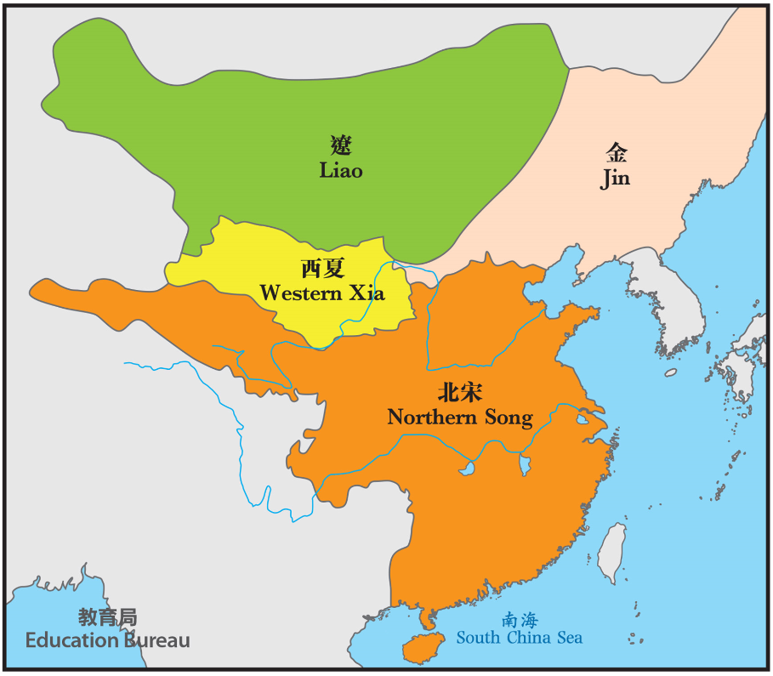
資料二：北宋末年中原與邊疆民族政權分布圖(公元1123年) (Source B: A map depicting the distributions of frontier ethnic groups during the late Northern Song Dynasty)(1123)

2. 在地圖上圈出北宋末年的邊境民族。(Circle those frontier ethnic groups during the late Northern Song Dynasty on the map.)

資料三：北宋滅亡及南宋建立 (Source C: The downfall of the Northern Song Dynasty and the establishment of the Southern Song Dynasty)
1. 公元1125年，北宋皇帝聯金滅遼。(Emperor of the Northern Song Dynasty formed an alliance with Jin to conquer the Liao in 1125.)
3. 公元1127年，趙構成為新皇帝，建立南宋。(Zhao Gou became the new emperor and the Southern Song Dynasty was founded in 1127.)
2. 公元1125及1127年，宋金大戰。金攻佔首都，並俘虜宋帝。北宋滅亡。(In 1125 and 1127, wars between Jin and Song happened. Jin captured the capital of Song and its emperors. The Northern Song Dynasty collapsed.)
根據資料三，回答以下問題。(Study Source C, and answer the questions.)

3. 北宋皇帝聯金滅遼有何壞處？試圈出答案。(What was the disadvantage of the emperor of the Northern Song Dynasty in forming an alliance with Jin? Circle your answer.)

在宋金聯合滅遼的過程中，金朝統治者看到宋朝 軍事力弱 / 文化衰落 ，故金朝破壞盟約，向北宋發動戰爭。(The military weakness / cultural decline of the Song army was observed by Jin during the joint military campaign. Hence Jin broke the alliance and began the wars with Song.)

4. 北宋亡於哪個邊境民族？試圈出答案。(Which of the following ethnic group conquered the Northern Song Dynasty? Circle your answer.)
A. 金(Jin)
B. 遼(Liao)
C. 西夏(Western Xia)
D. 蒙古(Mongol)

II. 外患與南宋(Foreign invasions and the Southern Song Dynasty)

資料四：岳飛(Source D: Yue Fei)
岳飛(公元1103-1142年)是南宋時期一名出色的將軍，他一生忠心為國。(Yue Fei (1103-1142) was a loyal and outstanding general of the Southern Song Dynasty.)
https://chiculture.org.hk/en/china-five-thousand-years/1911 (英文English)
https://chiculture.org.hk/tc/china-five-thousand-years/1911 (中文Chinese)

(中文Chinese)
(英文English)

資料五：南宋與金(Source E: The Southern Song Dynasty and Jin)
公元1140 年，岳飛帶領軍隊與金兵作戰，收復了許多中原失地。(In 1140, Yue Fei led his Army to attack the Jin army and recovered many lost territories in the Central Plains.)

不過，昏庸的南宋皇帝卻與金朝議和，命令岳飛從前線撤兵，又解除了他的兵權。(However, the incapable emperor of the Southern Song Dynasty made peace with Jin and ordered Yue Fei and his army to withdraw from the frontline and stripped his military power.)
公元1141年，南宋與金簽定詔興和議，雙方停止戰爭。(The Shaoxing Treaty was signed in 1141. It was the agreement that ended the military conflicts between the Southern Song Dynasty and Jin.)

公元1142 年，奸臣秦檜以「莫須有」（即「可能有」的意思）的罪名把岳飛迫害死了。(In 1142, Qin Hui, an evil prime minister, ordered Yue Fei to commit suicide under baseless charges.)

根據資料四及五，回答以下問題。(Study Sources D and E, answer the questions.)

5. 岳飛是什麼出身？試圈出答案。(What was the status of Yue Fei? Circle your answer.)
A. 武人(military general)
B. 文人(civil official)

6. 岳飛用甚麼方法「精忠報國」(盡心盡力地貢獻國家)？試圈出答案。(How did Yue Fei serve his country loyally? Circle your answer.)
A. 考試做官(To join the civil-service examination and became an official)
B. 當兵上戰場(To join the army to defend his country)
C. 做個好市民(To be a good citizen)

7. 以下哪個是南宋初年的威脅？試圈出答案。(Which of the following ethnic group threatened the Southern Song Dynasty in the early period? Circle your answer.)
A. 金(Jin)
B. 遼(Liao)
C. 西夏(Western Xia)
D. 蒙古(Mongol)

8. 填充：金入侵南宋，誰人主張出戰？誰人主張議和？(Fill in the blanks. Jin invaded the Southern Song Dynasty. Who wanted to fight against the Jin army? Who wanted to negotiate for peace?)
主張出戰(To fight against the Jin army) | 主張議和(To negotiate for peace)
岳飛(Yue Fei) | 南宋皇帝 / 趙構(The emperor of the Southern Song Dynasty / Zhao Gou)
 | 秦檜(Qin Hui)

9. 岳飛主戰的原因是甚麼？試圈出答案。答案可多於一個。(Why did Yue Fei want to fight against the Jin army? Circle your answer. There may be more than one correct answer.)
A. 他統領的軍隊不斷取得勝利(The army under his command kept winning.)
B. 他想做新的皇帝(He wanted to become an emperor.)
C. 他已經為國家收復不少失地(He recovered many lost territories of the Southern Song Dynasty.)
D. 他擔心失去將軍的工作(He was worried about losing his job as a general.)

10. 南宋向金求和，命令岳飛從前線撤兵的最主要原因是甚麼？試圈出答案。(What was the main reason for the Southern Song Dynasty to withdraw Yue Fei from the frontline and negotiate for peace? Circle your answer.)
A. 南宋不可能取勝(The Southern Song Dynasty could not win)
B. 怕抗金將士的力量壯大，威脅其統治(The general would seize power through the military campaigns and threatened the rule of the Southern Song Dynasty)
C. 金朝已向宋朝投降(Jin had already surrendered to the Southern Song Dynasty)

11. 課堂活動：角色扮演(Classroom activity: Role play)
請代入岳飛的角色，在被處死前，你對南宋皇帝有甚麼勸告？為他設計對白，然後在課堂上演繹出來。(If you were Yue Fei, what advice would you offer to the emperor of the Southern Song Dynasty before your execution? Please write down the advice and act it out in the lesson.)
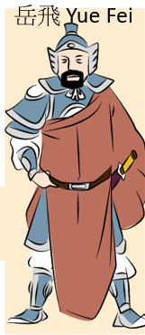

III. 外患與南宋滅亡(Foreign invasions and the downfall of the Southern Song Dynasty)

資料六：南宋地圖(公元1208年)(Source F: The map of the Southern Song Dynasty)(1208)

12. 在地圖上圈出南宋的邊境民族。(Circle the frontier ethnic groups of the Southern Song Dynasty on the map.)

資料七：南宋與蒙古(Source G: The Southern Song Dynasty and Mongol)
南宋每年向金朝進貢，歷時超過一百年。後來，南宋與蒙古結盟，消滅金朝。(After paying tribute to Jin for over 100 years, the Southern Song Dynasty allied with the Mongol to conquer Jin.)
不過，公元1235年，蒙古軍滅金國後，開始入侵南宋。(However, once the Mongol had conquered Jin in 1235, they turned to the Southern Song Dynasty.)
公元1271年，忽必烈建立元朝。(In 1271, Kublai Khan established the Yuan Dynasty.)
公元1276年，元軍佔領首都，南宋皇帝被俘虜。(In 1276, the Yuan army captured the capital of the Southern Song Dynasty and the emperor of the Southern Song Dynasty became the captive.)
南宋皇帝被元軍追殺，他們向南逃亡。(Emperors of the Southern Song Dynasty were chased by the Yuan army and they fled to the south.)
公元1279年，元軍發動大規模進攻，南宋正式滅亡。(In 1279, the Yuan army launched a massive attack on the Southern Song Dynasty. The Southern Song Dynasty collapsed.)

13. 根據資料三及七，北宋與南宋的滅亡有何相似的地方？(Study Sources C and G, what were the similarities between the downfalls of the Northern and the Southern Song Dynasties? Fill in the blanks.)

 | 北宋(Northern Song Dynasty) | 南宋(Southern Song Dynasty)
它被哪個邊境民族 / 政權的入侵，導致滅亡？(Which ethnic minority group’s / regime’s invasion led to its downfall?) | 金朝(Jin Dynasty) | 蒙古(Mongol)
哪裏被佔領？(Where was captured?) | 首都(capital) | 首都(capital)
誰被俘虜？(Who was captured?) | 皇帝(emperor) | 皇帝(emperor)

小總結 A short summary
宋朝與邊境民族政權有時打仗，有時和好，北宋和南宋都是因邊境民族入侵而滅亡。(The Song Dynasty fought and / or made peace with the surrounding frontier ethnic regimes from time to time. The downfalls of both the Northern and the Southern Song Dynasty were due to foreign invasions.)

課節五： 宋朝與香港(The Song Dynasty and Hong Kong)

1. 根據圖片下方的文字提示，請將A至D選項按事件先後次序排列。(According to the hints under the pictures, please arrange the events in chronological order. Write down A to D for the correct answers in the brackets provided.)
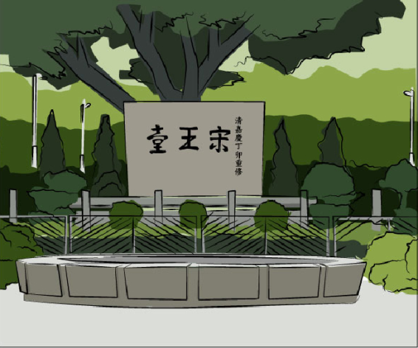  (A) | 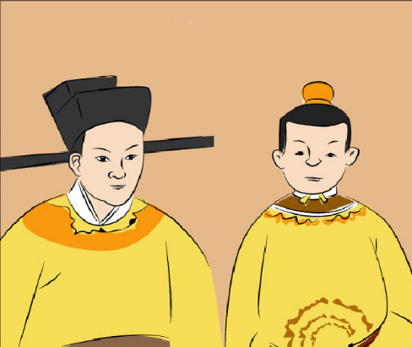  (B)
「宋王臺」碑石現在位於九龍城區内的宋王臺公園。(“Sung Wong Toi” [Song Emperor's Terrace] now stands in Sung Wong Toi Garden of Kowloon City.) | 南宋末代皇帝帝昰和帝昺為逃避元軍追殺，曾躲藏於九龍城的山丘上。(When Emperor Shi and Emperor Bing fled from the Mongol invaders, they took refuge on a hill of Kowloon City.)
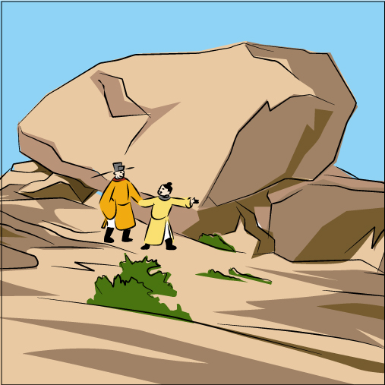  (C) | 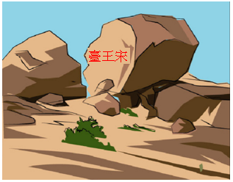  (D)
帝昰和帝昺經常在海邊一個小山上遊玩，後人稱這座山為「聖山」。 (Emperor Shi and Emperor Bing played on the "Sacred Hill" along the seashore.) | 後人為紀念宋帝來港事跡，在山上大石刻上「宋王臺」。(People inscribed the words "Sung Wong Toi" on the huge rock in memory of the fact that two emperors of the Song Dynasty once took refuge there.)

答案(Answer)：( B ) ( C ) ( D ) ( A )

資料一：原聖山附近考古文物(Source A: Archaeological Heritage of former Sacred Hill)
1998年啟德機場關閉後，啟德新發展區的規劃，為九龍灣一帶提供了考古研究的契機。九龍灣原聖山附近的考古工作，發現了豐富的文化遺存。(Following the closure of Kai Tak Airport in 1998, the planning work for the Kai Tak Development Area has created opportunities for archaeological studies around Kowloon Bay. The archaeological work conducted in the environs of the former Sacred Hill at Kowloon Bay has unearthed an abundance of cultural remains.)
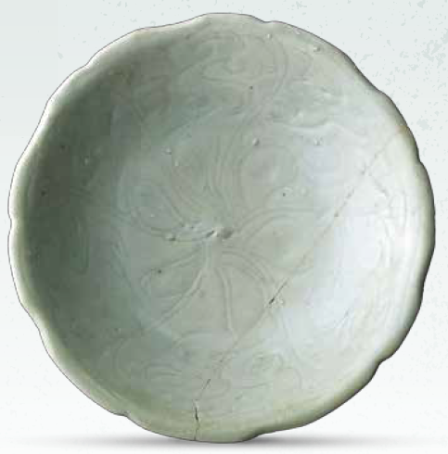
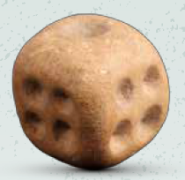
青釉劃花紋花口碗(Green Glazed Bowl with Foliate Rim and Carved Pattern)
宋元時期（960至1368年）
(Song-Yuan period (960 – 1368))
骰(Dice)
宋元時期（960至1368年）
(Song-Yuan period (960 – 1368))

(資料來源：古物古蹟辦事處：《聖山遺粹：啟德地區出土宋元文物展展覽小冊子》)

資料二：宋皇臺站(Source B:Sung Wong Toi Station)
宋皇臺站坐落九龍城區。在建造宋皇臺站期間，有大量宋元古物出土，站內設計亦揉合大量考古元素。(Sung Wong Toi Station is located in the Kowloon City district. With lots of relics from the Song-Yuan period unearthed during the construction, archaeological elements were included into the design.)

2. 請在以下地圖圈出宋王臺公園的位置。(Please circle the Sung Wong Toi Garden in the below map.)
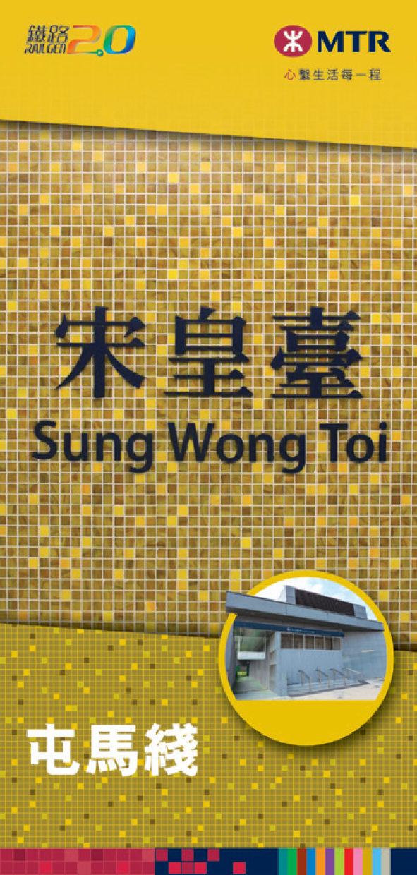
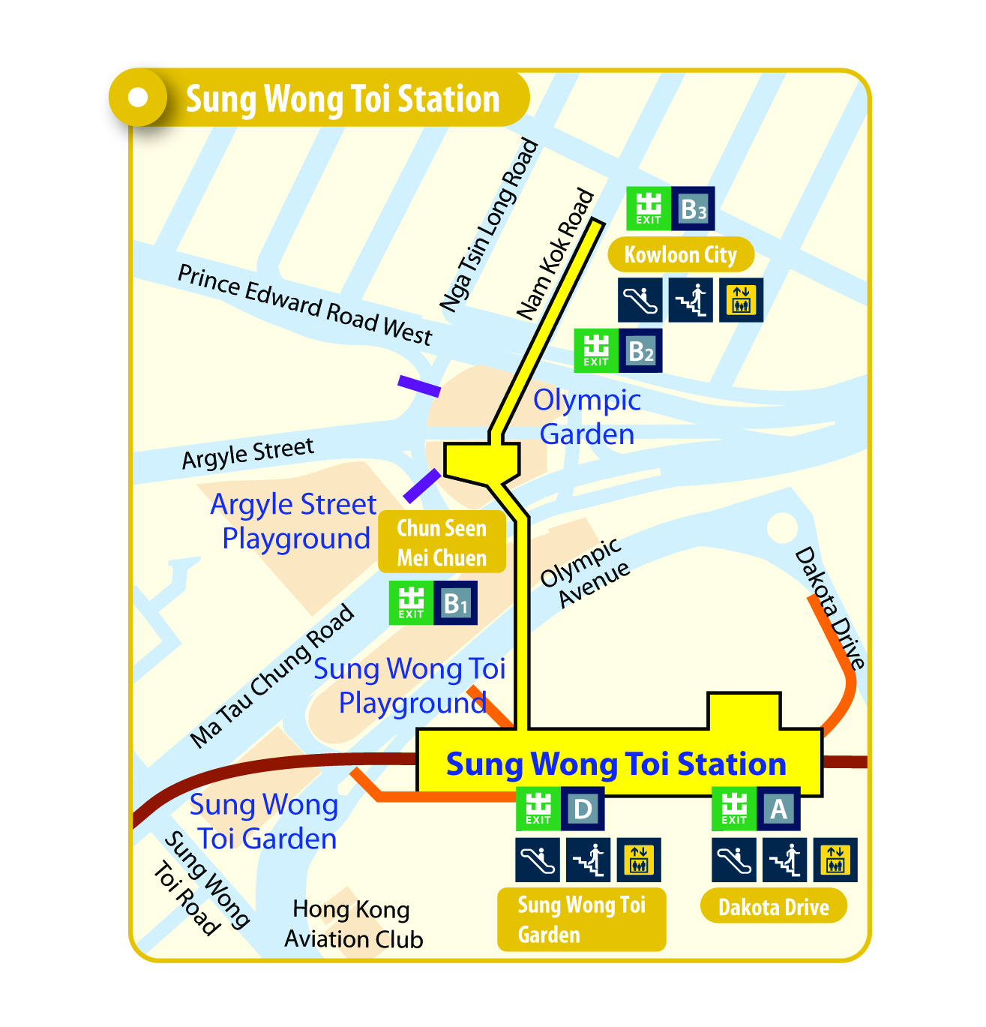

(圖像來源：https://mtr-tuenmaline.hk/tc/stations/sungwongtoi ，觀看日期：2021年6月30日。)
請觀看短片(Please view the video)
https://www.youtube.com/watch?v=w-5qPpCwSpI&t=14s

3. 根據資料二，宋皇臺站是港鐵屯馬線的新車站。(Study Source B, Sung Wong Toi Station is one of the new stations of Tuen Ma Line.)
車站已於2021年6月27日通車。(It commences services on 27 June 2021.)

資料三：宋元時代的古井(Source C: A stone well dated to the Song-Yuan period)
在建造宋皇臺站期間，工程團隊發現大量遺蹟，包括於現時車站中央位置發現宋元時代的古井及接連的引水槽。(A large quantity of relics was unearthed during the construction period of the Sung Wong Toi Station, including a square-shaped stone well dated to the Song-Yuan period and an associated water channel.)
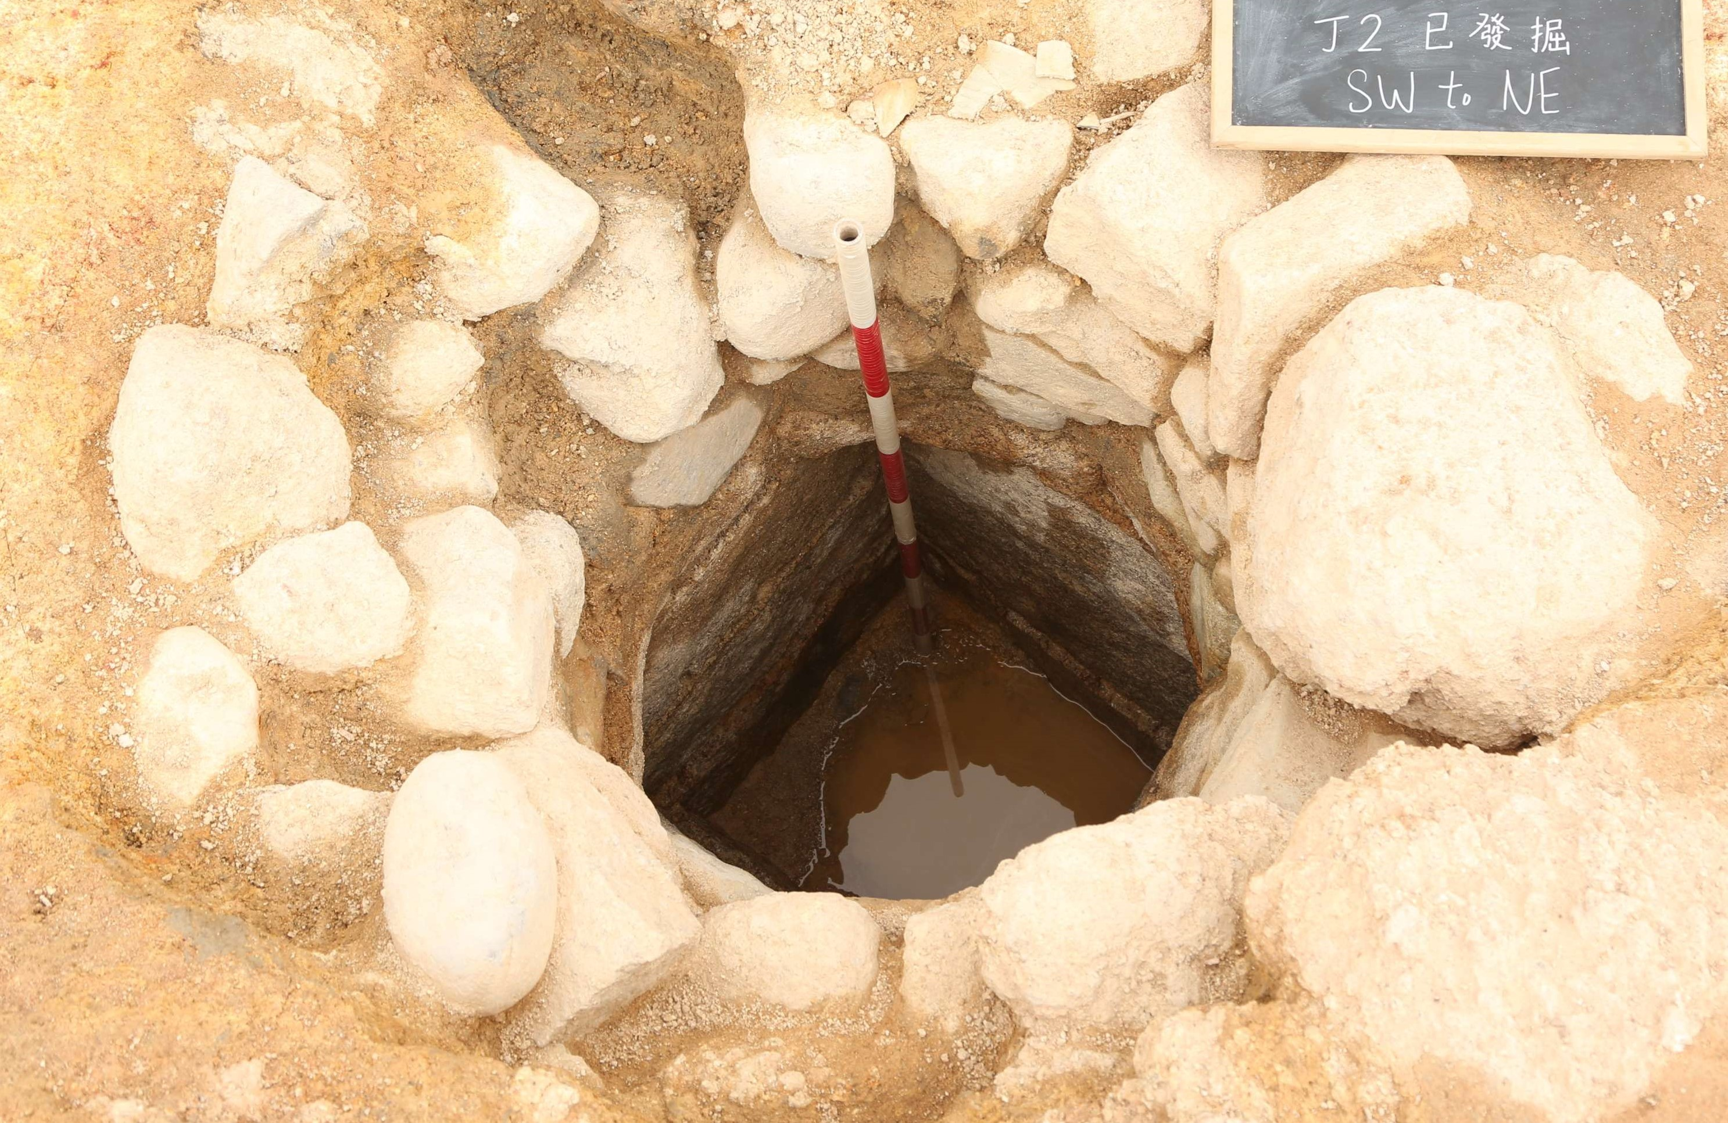

宋元時代的古井(A stone well dated to the Song-Yuan period)

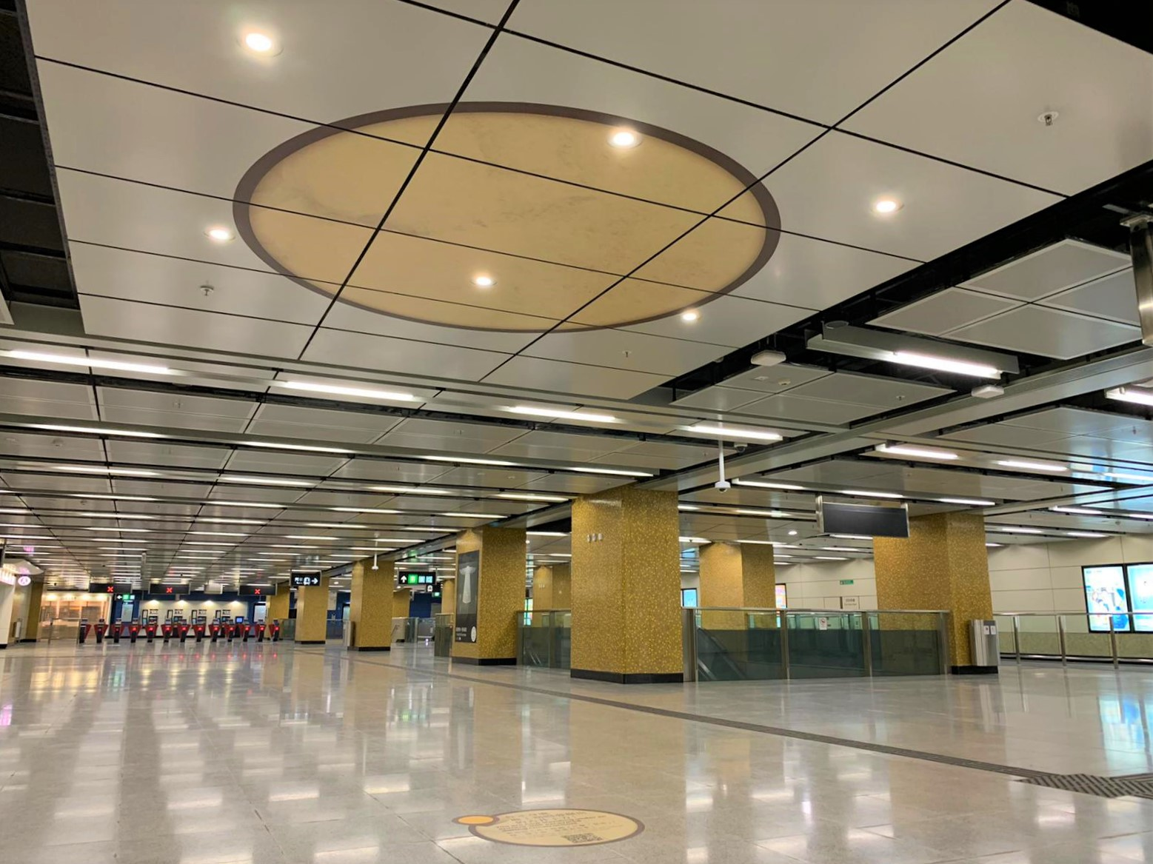

宋皇臺站內的古井位置示意圖(Indicative location of the well inside Sung Wong Toi Station)

(資料來源：http://203.105.11.193/ch/customer/community/relics_display_in_station.html，觀看日期：2021年6月30日。)
4. 活動(Activity)
宋皇臺站內設有兩個展櫃展示宋元時期的出土文物。請參觀宋皇臺站內這兩個文物展櫃或瀏覽以下網頁，並向同學介紹其中一項文物。(Two large display cabinets are provided in the Sung Wong Toi Station to showcase the archaeological relics of the Song-Yuan period. Please visit these two large display cabinets in the Sung Wong Toi Station or the following website. Introduce one of the archaeological relics to your classmates.)
https://www.amo.gov.hk/en/visitor-centre/exhibitions/sung-wong-toi-station/index.html (英文English)
https://www.amo.gov.hk/tc/visitor-centre/exhibitions/sung-wong-toi-station/index.html (中文Chinese)

(中文Chinese)
(英文English)

5. 根據資料一至三，填寫以下答案。(Study Sources A to C, and fill in the blank.)
從考古結果顯示香港於宋元時期已有人聚居。(As indicated by the archaeological findings, Hong Kong was already inhabited by people at the Song-Yuan period.)

小總結(A short summary)
「宋王」指的是南宋末年最後兩個小皇帝—帝昰及帝昺，因為逃避元軍追殺而逃到九龍。(“Sung Wong” refers to the last two young emperors of the Southern Song Dynasty, Emperor Shi and Emperor Bing, fled from the Yuan army to Kowloon.)

考古文物證明宋元時期，香港已有人居住。(Archaeological heritage proved that there were people living in Hong Kong as early as Song-Yuan Dynasties.)

附件一(Appendix I)

延伸活動(Extended Learning Activities)
資料一：宋代被稱為「中國的文藝復興」，一起探索中國與歐洲的「文藝復興」吧！
(Source A: Song Dynasty was known as the Chinese Renaissance. Let’s explore the Renaissance in China and Europe.)
 | 中國宋代(公元960-1279年)  (The Song Dynasty in China (960-1279)) | 歐洲文藝復興(公元1450-1600年)  (The Renaissance in Europe(1450-1600))
藝術  (Art) | 宋代山水畫追求意境。(Landscape paintings of the Song Dynasty pursued artistic conception.)  請觀看：《清明上河圖》(“Life along the Bian River at the Pure Brightness Festival” scroll painting)  (故宮博物院 The Palace Museum)  https://www.dpm.org.cn/collection/paint/228226.html (中文 Chinese)  https://en.dpm.org.cn/collections/collections/2009-10-19/990.html  (英文English)  (中文 Chinese) (英文 English) | 文藝復興時期，畫家繪畫方法重視寫實。(Renaissance painters sought greater realism in their arts.)  請觀看：《蒙羅麗莎》(Mona Lisa)  羅浮宮(Louvre Museum)  https://www.louvre.fr/en/explore/the-palace/from-the-mona-lisa-to-the-wedding-feast-at-cana

 | 中國宋代(公元960-1279年)  (The Song Dynasty in China (960-1279)) | 歐洲文藝復興(公元1450-1600年)(The Renaissance in Europe(1450-1600))
文學(Literature) | 蘇軾(公元1037-1101年)對宋代的文學發展具有重大影響力。(Su Shi (1037-1101) was highly influential in the development of literature during the Song era.)  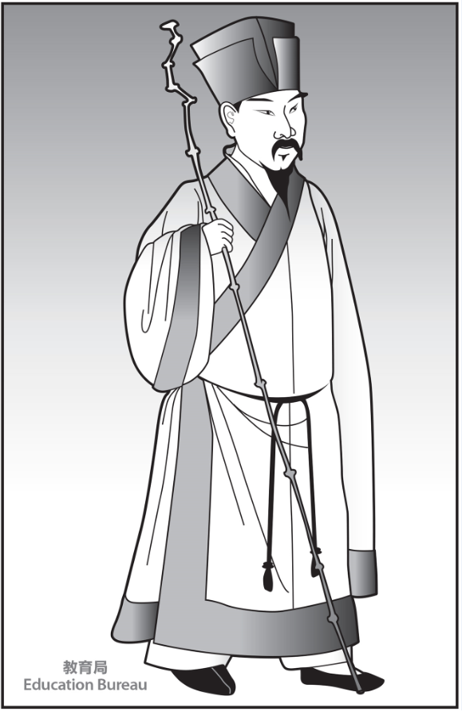  他擅長寫詩、詞、賦和散文。(He was good at writing Shi poetry, Ci poetry, Fu and prose essays.) | 莎士比亞(公元1564-1616年)是英國文藝復興的重要人物。(William Shakespeare (1564-1616) was the chief figure of the Renaissance in England.)  他擅長寫戲劇。(He was good at writing plays.)  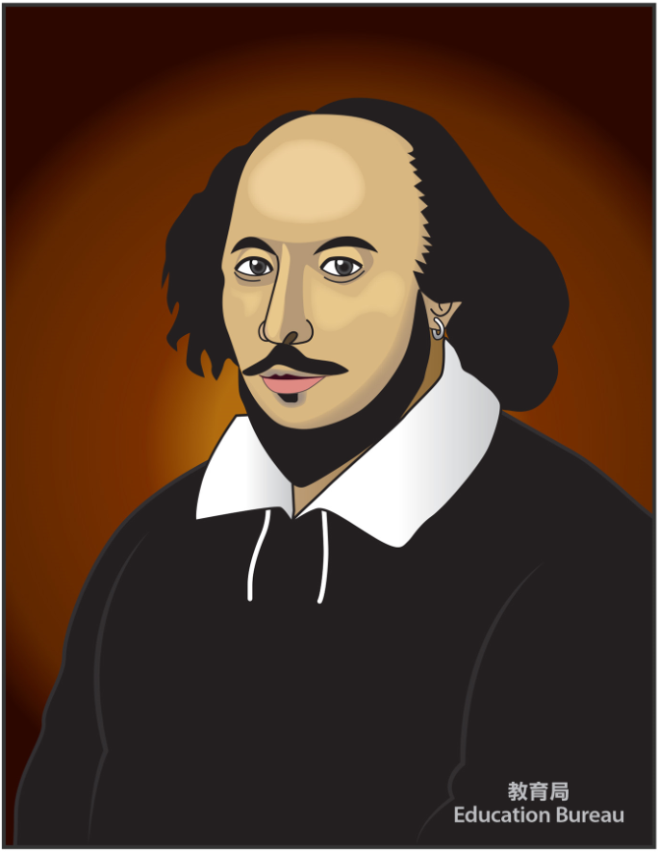

 | 中國宋代(公元960-1279年)  (The Song Dynasty in China (960-1279)) | 歐洲文藝復興(公元1450-1600年)(The Renaissance in Europe(1450-1600))
科技(Technology) | 約於公元1041-1048年間，畢昇發明活字印刷。(At around 1041-1048, movable-type printing was invented by Bi Sheng.)  (請觀看 Please view 7:15-9:21)  https://emm.edcity.hk/media/%E5%8D%B0%E5%88%B7%E5%8F%A4%E8%88%87%E4%BB%8A%20(%E4%B8%AD%E3%80%81%E8%8B%B1%E6%96%87%E5%AD%97%E5%B9%95%E5%8F%AF%E4%BE%9B%E9%81%B8%E6%93%87)/0_xel5jwwf | 公元1455年，約翰尼斯·谷騰堡在歐洲發明活字印刷術。(In 1455, mechanical movable type printing press was invented by Johannes Gutenberg in Europe.)  (請觀看 Please view)  https://m.youtube.com/watch?v=1kOmdSIpCm4

根據資料一，回答題目。(Study Source A, and answer the questions.)

1. 填充：「中國的文藝復興」與「歐洲的文藝復興」有何相似的地方？(Fill in the blanks: What were the similarities between the Renaissance in China and Europe?)
宋朝及歐洲文藝復興是一個 藝術 、文學 和 科技 興盛的時代。(The Song Dynasty and the Renaissance in Europe were the eras during which art , literature and technology flourished.)

2. 發明活字印刷有何好處？試圈出答案。(What was the advantage of the invention of movable-type printing? Circle your answer.)
A. 對文學、知識及學說的傳播作出了傑出的貢獻(To enhance the spread of literature, knowledge and thoughts, and have great contributions)
B. 促進經濟交流(To promote economic exchanges)

小總結(A short summary)
宋代被稱為「中國的文藝復興」，因為它與「歐洲的文藝復興」一樣，是藝術、科技和文化發達的時代。(Song Dynasty was called by some as the “Chinese Renaissance” because of its similarities with the Renaissance in Europe. Both periods witnessed great achievements in art, technology and culture achievements.)

如對本教材有任何意見，可聯絡課程發展處個人、社會及人文教育組：
黃浩明先生（erichmwong@edb.gov.hk; 35406829）或
羅嘉恩女士（lokayan@edb.gov.hk; 28925882）

